SilentFiber™ Blade Baffle Installation Guide
Supplies needed:
- SilentFiber Polyester Acoustic Blade Baffle
- Baffle hangers and cable (included)
- Leveling tool
Step 1: Using the corkscrew end of the baffle hanger, score 2 small holes in the top middle of the panel (12” from the end on left and right, 24” apart in the middle)
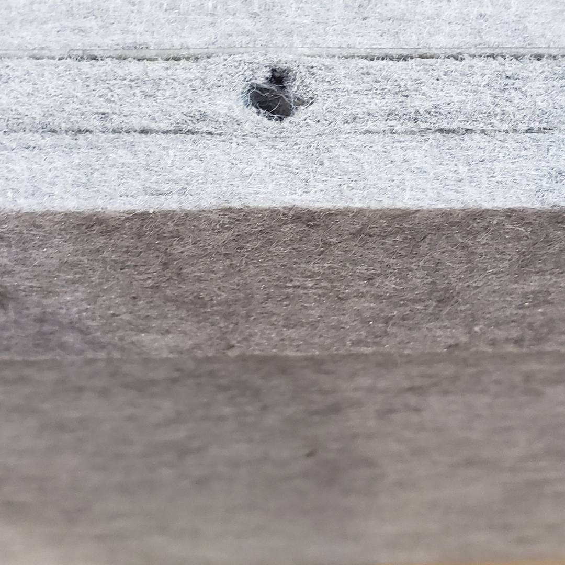
Step 2: Insert the baffle hangers and twist to the right until it is tight.
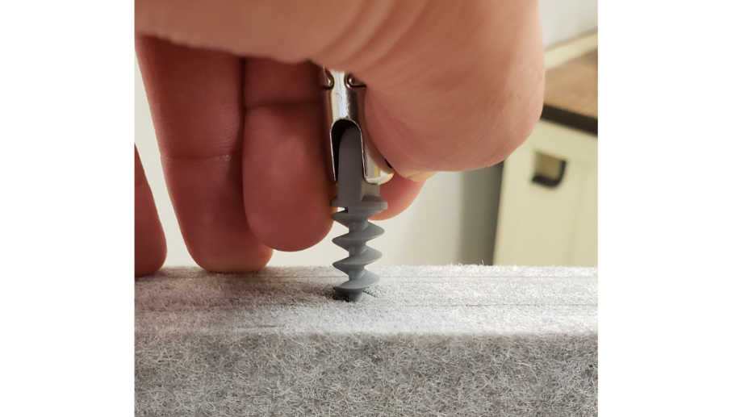
Step 3: Wipe the cable with a damp cloth to clean it.
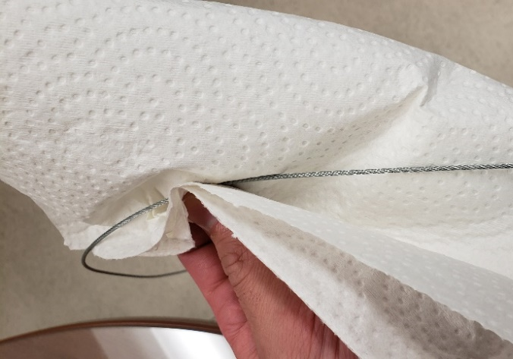
Step 4: Locate the area in which the baffle will be hung, and suspend the cable from the ceiling. (Be sure to hang the cabling 24” apart from one another)
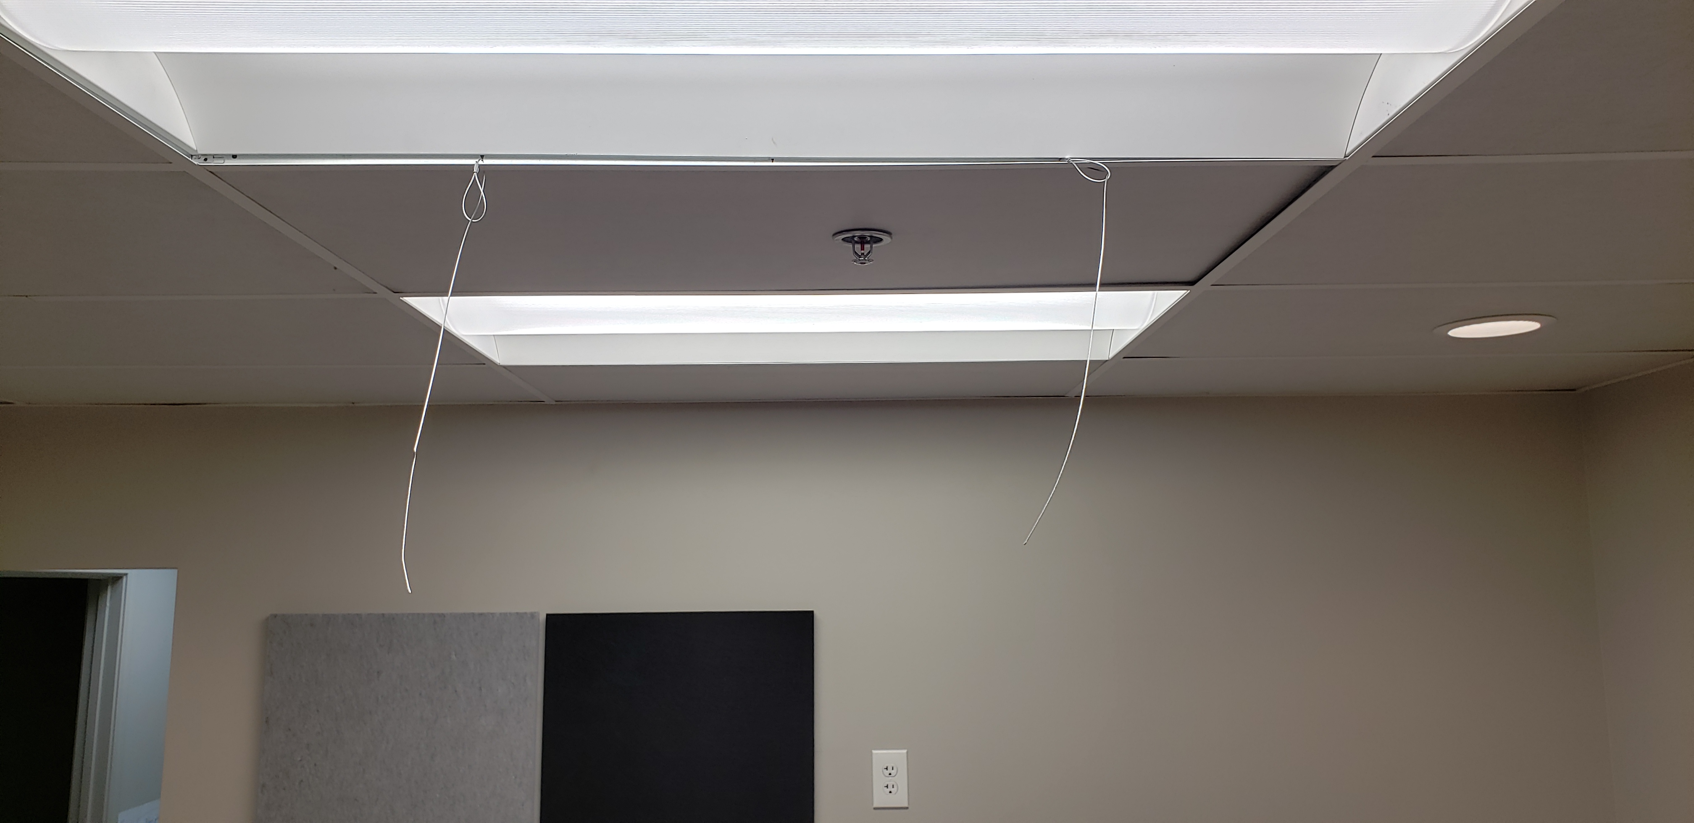
Step 5: Pinch the sides of the hanger and run the cable through the open hole at the top. Releasing your fingers from the hanger (with the cable in place), will lock the hanger onto the cable.
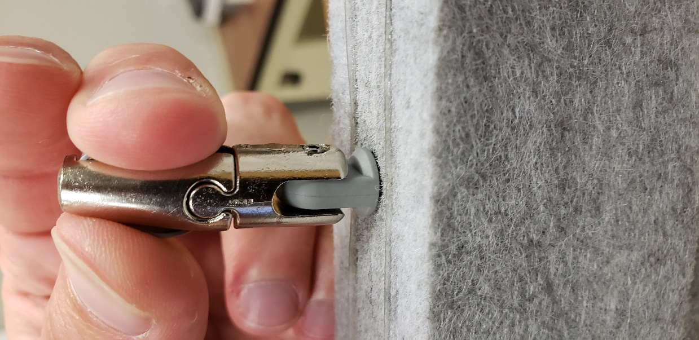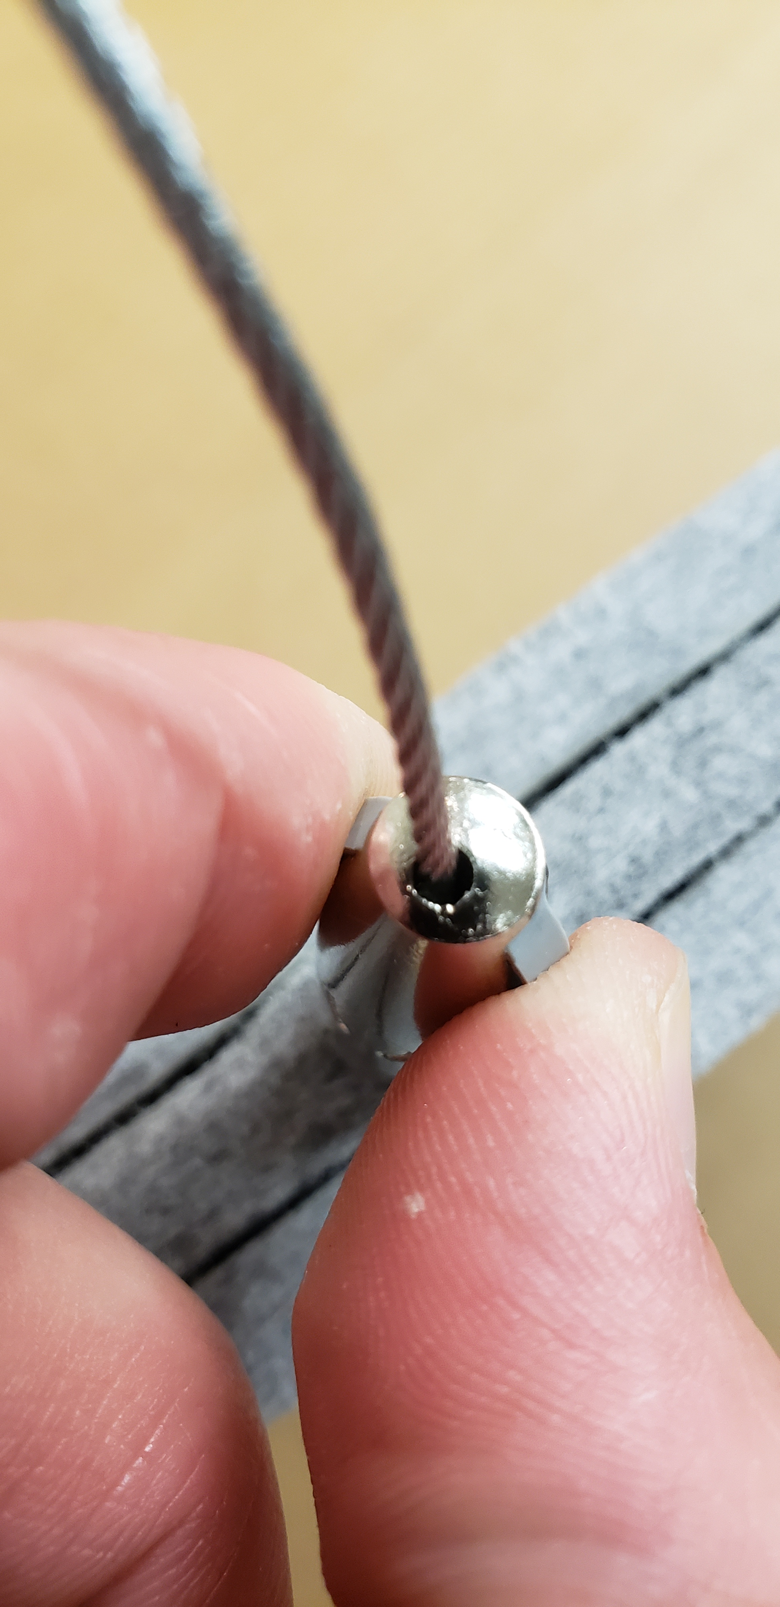
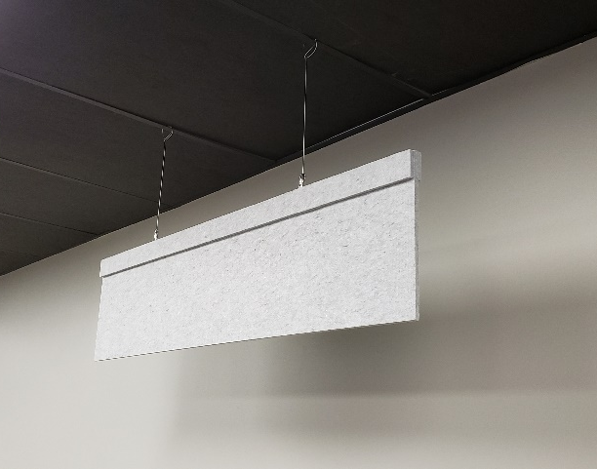
Step 6: Using a leveling tool, make sure your Blade Baffle is completely level.
*For additional reinforcement, add a small drop of glue to the corkscrew end of the hanger before securing them in place.
For more information, contact us:
+1 (877) 399-9697
info@soundacousticsolutions.com
www.soundacousticsolutions.com
Follow us on social media:


